K.R. MANGALAM UNIVERSITY

SCHOOL OF ENGINEERING AND TECHNOLOGY



OPERATING SYSTEMS: LAB ASSIGNMENT 2
COURSE CODE: ENCS351
NAME: SIDDHANT JHA
ROLL NO.: 2301730219

COURSE: BTECH CSE (AI and ML) LINK TO GIT REPOSTORY: https://github.com/siddhantjha313/OPERATING-SYSTEM-LAB-FILES
LAB ASSIGNMENT 2

Problem Title:
Implementation of System Startup, Process Creation, and Termination Simulation in Python.
Tools/Technology Used:
- Python 3.x
- multiprocessing module
- time module
- logging module
Problem Statement:
Modern operating systems are responsible for initializing system components, creating processes, managing execution, and gracefully shutting down. This lab aims to simulate these core concepts using Python, helping students visualize how processes are handled at the OS level. The focus is on creating a simplified startup mechanism that spawns multiple processes and logs their lifecycle using the multiprocessing and logging modules. This hands-on simulation enhances conceptual clarity and promotes coding proficiency in scripting real-world OS behavior.

Learning Objectives:
- Upon completing this lab, students will be able to:
- Understand the concepts of system booting, process creation, and termination.
- Develop Python scripts using multiprocessing and logging modules.
- Simulate system behaviour using programming constructs.

Assignment Tasks:
  - Write a Python script to simulate a basic system startup sequence.
  - Use the _{multiprocessing} module to create at least two child processes that perform dummy tasks.
  - Implement proper logging to track process start and end times.
  - Generate a log file (_{process_log.txt}) to reflect system-like behavior.
  - Submit the Python script and log file along with a short report explaining your implementation.
Sub-Tasks:
  - Sub-Task 1: Initialize the logging configuration to capture timestamped messages.
  - Sub-Task 2: Define a function that simulates a process task (e.g., sleep for 2 seconds).
  - Sub-Task 3: Create at least two processes and start them concurrently.
  - Sub-Task 4: Ensure proper termination and joining of processes, and verify the output in the log file.
Stepwise Subtask Allocation:
Sub-Task 1: Initialize the logging configuration
Objective: Set up the logging system to log messages with timestamps and process names.

import logging # Setup logger logging.basicConfig( filename='process_log.txt', level=logging.INFO,
format='%(asctime)s - %(processName)s - %(message)s'
)

Sub-Task 2: Define a function that simulates a process task
Objective: Write a function that mimics the work of a system process.

import time
# Dummy function to simulate a task def system_process(task_name):
logging.info(f"{task_name} started") time.sleep(2) # Simulate task delay logging.info(f"{task_name} ended")

Sub-Task 3: Create at least two processes and start them concurrently
Objective: Use the multiprocessing module to initiate parallel tasks.

import multiprocessing if name == ' main ': print("System Starting...") # Create processes p1 = multiprocessing.Process(target=system_process, args=('Process-1',)) p2 = multiprocessing.Process(target=system_process, args=('Process-2',))
# Start processes
p1.start() p2.start()
Sub-Task 4: Ensure proper termination and verify logs
Objective: Wait for processes to complete and confirm the shutdown.

# Wait for processes to complete p1.join() p2.join()
print("System Shutdown.")

Program Code with Explanation:
The following Python script simulates a simple system startup. It creates a few dummy processes which perform simple tasks. Each process logs its start and end, and the logger records the process flow, simulating system behavior.

# Import required libraries import multiprocessing import time import logging
# Setup logger
logging.basicConfig(filename='process_log.txt', level=logging.INFO, format='%(asctime)s - %(processName)s - %(message)s')
# Dummy function to simulate a task def system_process(task_name): logging.info(f"{task_name} started") time.sleep(2)
logging.info(f"{task_name} ended")

if name == ' main ':
print("System Starting...")

# Create processes p1 = multiprocessing.Process(target=system_process, args=('Process-1',)) p2 = multiprocessing.Process(target=system_process, args=('Process-2',))

# Start processes
p1.start() p2.start()

# Wait for processes to complete p1.join() p2.join()

print("System Shutdown.")

Results:

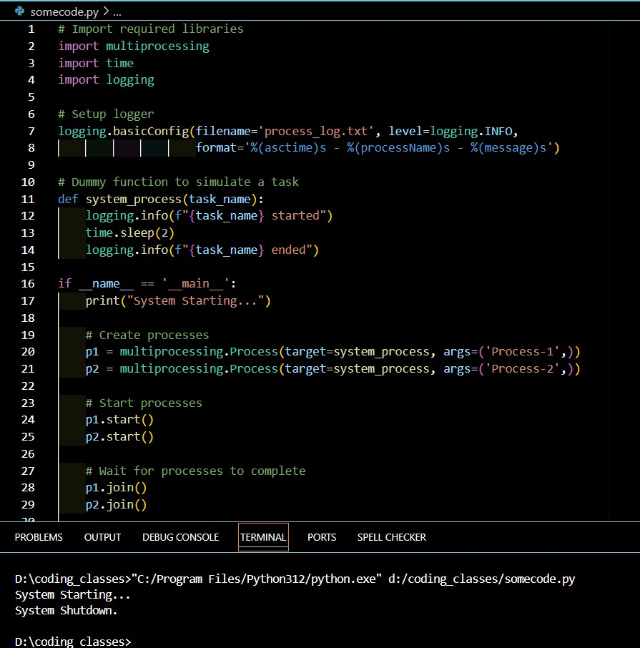

Expected Output:
- The terminal displays 'System Starting...' and 'System Shutdown.'
- A log file 'process_log.txt' is generated which records the start and end of each process.

